1.

#include <iostream> // 含括iostream.h檔案

#include <stdlib.h> // 含括stdlib.h檔案

using namespace std;

int main(void)

{

int num; // 宣告整數num

num=3; // 將num設值為3

cout << "I have " << num << " apples." << endl;

cout << "You have " << num << " apples, too." << endl;

return 0;

}

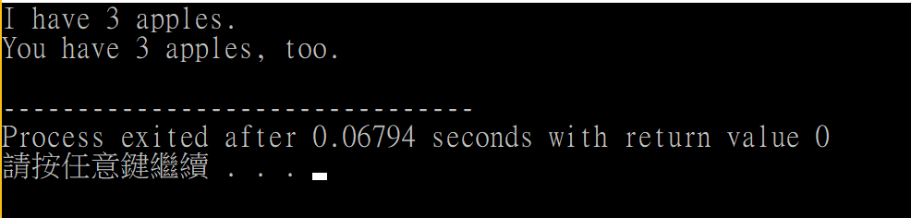

2.

#include <iostream>

using namespace std;

int main(void)

{

int n1,n2;

n1=3,n2=5;

cout << (n1+n2)/2 << endl;

return 0;

}

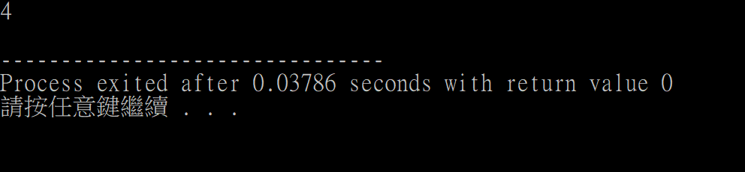

3.

#include <iostream>

#include <cstdlib>

using namespace std;

int main(void)

{

int num=2;

cout << "num= " << num << endl;

system("pause");

return 0;

}

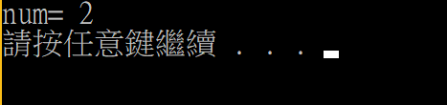

4.

#include <iostream>

#include <cstdlib>

using namespace std;

int main(void)

{

int a,b;

a=8;

b=10;

cout << "a= " << a << endl;

cout << "b= " << b << endl;

system("pause");

return 0;

}

